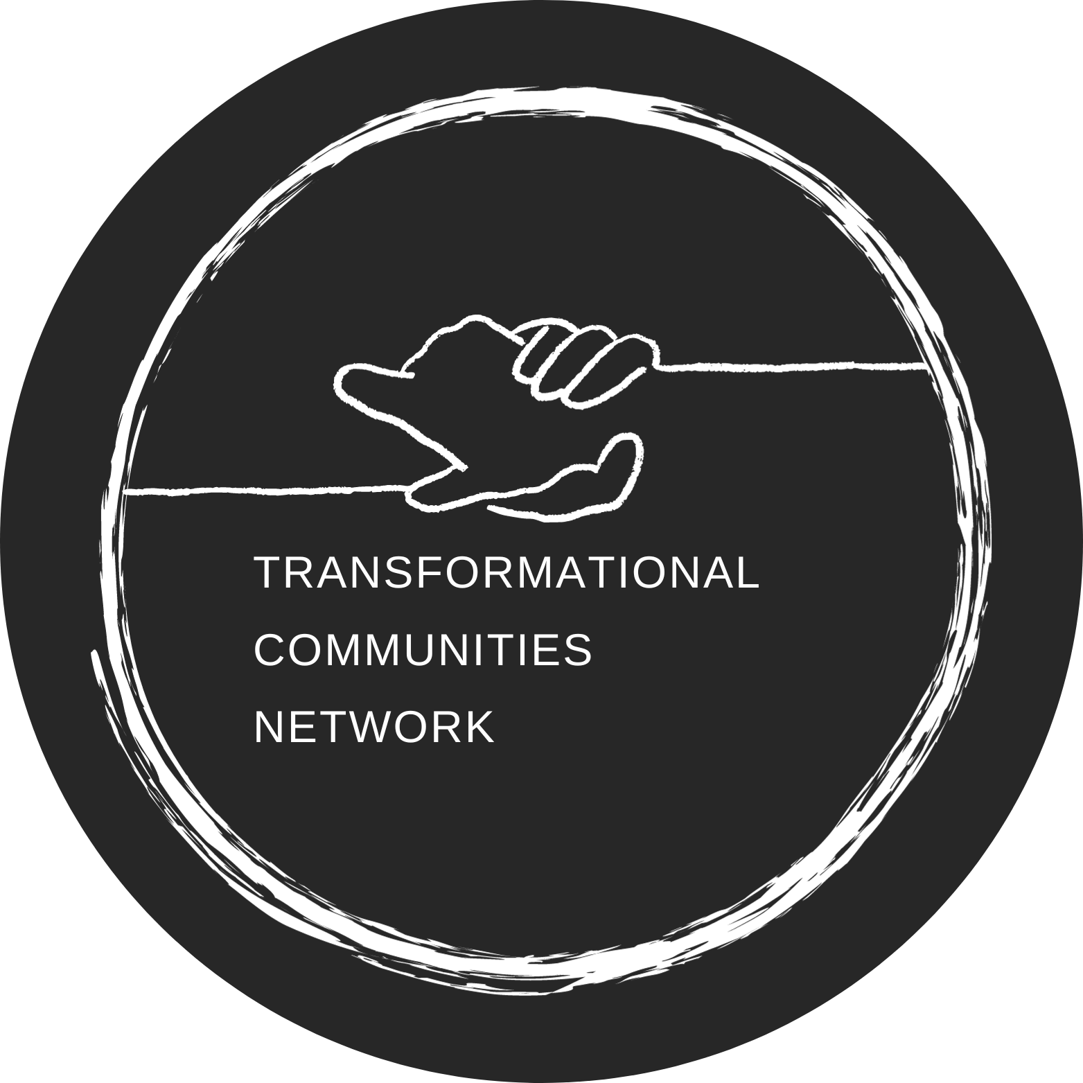
 | Transformational Communities Network  APPLICATION FORM  2024 - Class 8 | 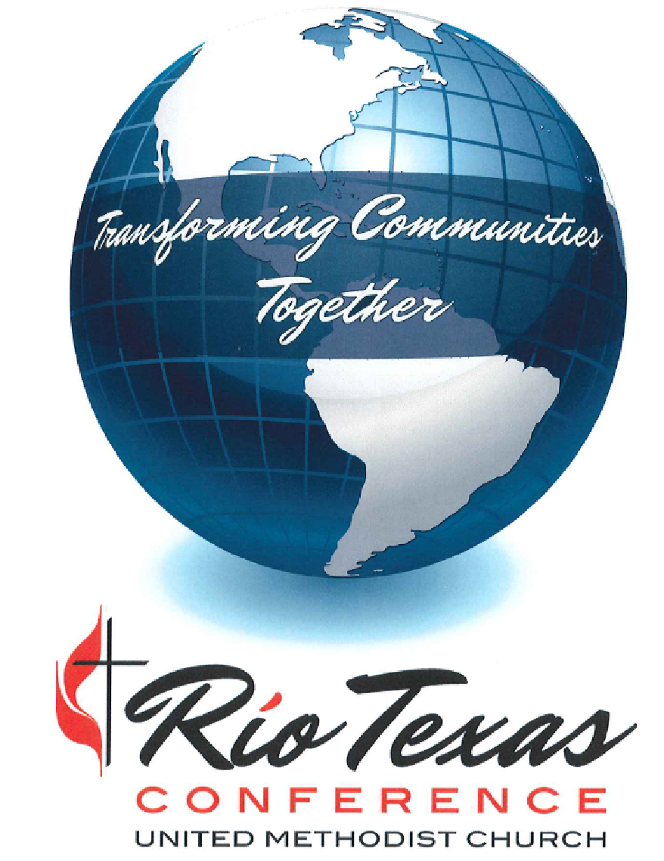
Deadline for team application submittal is Tuesday – January 31, 2024
Questions? - CONTACT Bob Clark at bclark@riotx.org / 210.837.0923
Submit completed application form to the Mission Service, & Justice Ministries Office
to bclark@riotx.org / cc: nicolea@riotexas.org

GENERAL INFORMATION
Church |  | Pastor / Staff

Physical Address |  | City |  | Zip Code + 4

Website
Facebook

Church Membership Size |  | Average Worship Attendance

District |  | District Superintendent

TEAM INFORMATION
 | Name | Affiliation | Phone Contact # | Email Address
1 |  | Pastor or Staff Person
2 |  | Community Member
3 |  | Community Member
4 |  | Church Member
5 |  | Church Member
6
7
8
9
10

Teams will consist of both church and outside community members, and the pastor or a staff or volunteer person appointed by the pastor. Teams should reflect the diversity of the local community in terms of ethnicity, age, and gender. Please provide a full roster should your team consist of more than 5 persons.

TEAM COORDINATOR

Name | Phone Contact # | Email Address

Each team is required to have a coordinator who will be the liaison between the team and the TCN program.

MINISTRY PROFILE
Please provide information and reflection on the following questions. Offer as much information, insight, and stories as desired or necessary.
- Provide a brief history of the church.

- Describe the church’s relationship with the community. Please provide a description of key activities, relationships, lessons learned, and outcomes.

- How has transformation occurred within the congregation and the community through these relationships and ministries?

- What has been the church’s / community’s exposure to or interaction with the asset-based community development process?

- What is the story in which the church has seen itself over the past year? Do you see a Biblical parallel? What books have been read? What are some points of conversation and learning?

- List / describe the church’s and community’s assets, gifts, and talents. How have these assets, gifts, and talents worked together for mutual outcomes and benefits?

- List / describe community partners and collaborative work within the community.

- Describe challenges or issues the community wishes to or is currently addressing. What has been the role of the church in this work?

- What transformational outcomes do you wish to see happen in the church and community over the next 3 years?

- What do you hope to learn from this program that will enhance your ministry?

- Other information you wish to offer.

Transformational Communities Network Covenant of Participation

As a Transformational Communities Network Team, we understand, affirm and covenant to follow program expectations:
- Teams and individuals will be expected to invest appropriate time in preparation for each session and attend all online sessions as well as invest time in the application of what is learned in the life of community and congregation. Those signing below have reviewed the estimated time commitments in the Program Schedule and Timeline.

- Each team will appoint one member to the role of Team Coordinator. This person will be responsible for communicating with the Transformational Communities Network assigned Journey Partner, scheduling additional trainings and / or workshops, and facilitating communication within the team.

- Teams will consist of both church and outside community members, and the pastor or a staff or volunteer person appointed by the pastor. Teams should reflect the diversity of the local community in terms of ethnicity, age, and gender.

- Because Transformational Communities Network is aimed at the transformation of the church and community, each team is expected to discover ways to share their learnings with their congregations.

Team Pledge Affirming the Transformational Communities Network Covenant
 | Name | Affiliation | Team Member Signature
1 |  | Pastor or Staff Person
2 |  | Community Member
3 |  | Community Member
4 |  | Church Member
5 |  | Church Member
6
7
8
9
10

Please obtain a signature from your district superintendent affirming his or her support of your team’s participation in TCN.

District Superintendent Signature: Date:

